Drive Chains
The drive chain of a motorcycle is one of the most important parts of a bike and yet normally gets the least attention. The standard drive-chain of older Honda motorcycles is of the "Roller Chain" type. The chain consists of two major parts, 1) the pin link and 2) the roller link.

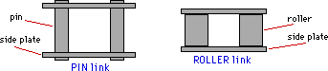
Both links get their linear strength from the side plates that keep them together. A "Heavy Duty" chain will have thicker, stronger side plates and thus greater overall strength. The pin link is very simple in design having only two rods or pins connecting the side plates. The roller link is more complex, consisting of two hollow bushings connecting the side plates surrounded by a movable roller.

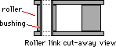
There are several types of drive chains:
- Standard: as described above.

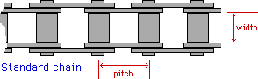
Common Drive Chains
Chain reference # | Pitch | Width
415 | 1/2 inch | 3/16 inch
420 | 1/2 inch | 1/4 inch
428 | 1/2 inch | 5/16
520 | 5/8 inch | 1/4 inch
525 | 5/8 inch | 5/16 inch
530 | 5/8 inch | 3/8 inch
630 | 3/4 inch | 3/8 inch
- O-Ring: similar to the standard but equipped with a rubber o-ring at each end of the pin. This o-ring traps in lubricant and keeps out road grit and moisture, thus prolonging the life of the chain.

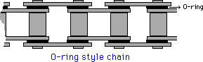
- Self-Lubricating: these chains incorporate oil-impregnated sintered metal bushings inside the rollers that gradually release oil to the chain.
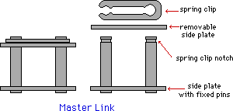
Master link: most motorcycle chains are connected into a loop by a master link. This is a single pin link with extended pins that allow the attachment of a removable side plate. The side plate is held in place by a spring clip.
Endless Chain: some motorcycles are equipped with an endless chain that does not contain a master link but are connected back unto itself when produced. These chains must be removed by removing the swingarm of the bike.
Maintenance:
The more you care for your chain, the longer it will last. For all riders, a yearly removal, cleaning and check-up is a must. If you are an avid rider this procedure may be repeated each month or sooner.
- remove the chain from the bike and soak in kerosene (I know gasoline will also clean a chain but due to its fire potential, use kerosene).
- if road grime and slight rust is a problem, scrub lightly with a hard bristle or metal brush.
- hang the chain over the pan of kerosene and drip dry.
- work your way down the chain testing the rollers and flexibility between each link. If you find links that will not flex freely even after forcing them, the chain needs replacing.
- place the chain on the floor and measure out 1 foot. Grab the chain at each end of this foot length and push the chain links together. Now pull outward on the chain and note any change in its length. It is recommended that this movement be no more than 1/4 inch. Check the rest of the chain in 1 foot lengths. If the slack is more than 1/4 inch for any foot, the chain should be replaced.
- re-lube the chain.
- This is commonly done by using one of the aerosol can chain lubes available. CAUTION: if your chain is of o-ring design, make sure the chain lube is compatible.
- A second way to lube your chain is by purchasing a can of solid lube. This material has to be heated, melting the solid, and the chain dipped in. The chain is hung over the can and allowed to drain and harden. This form of lube is longer lasting and will protect your chain the most.
- reinstall your chain and set the slack to your manuals specs. If the chain adjuster on your rear axel indicates that the chain needs replacing, do so.
- the master link spring clip open end MUST face away from the direction of rotation.

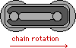
Sprockets
When ever you check your chain check your rear and drive sprockets also. The teeth on both sprockets should be uniform and symmetric. If they appear hooked or worn, they probably need replacing.

